IYG Term 2 – Foundation

Mark schemes
Q1.
(a) 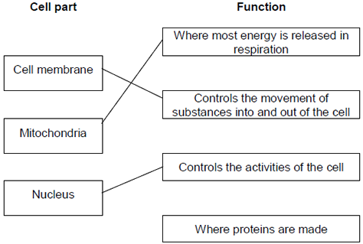
extra lines cancel
3
(b) Cell wall
in either order
1
Chloroplast
allow (permanent) vacuole
1
[5]
Q2.
(a) (i) diffusion
1
(ii) carbon dioxide
accept CO₂ / CO2
do not accept CO²
1
(iii) red blood cells
1
(b) 70
if no / incorrect answer then
70 000 000
or
280 x 0.25 gains 1 mark
ignore doubling the answer
2
(c) allows more gas / oxygen / CO₂
(exchange)
do not accept air
1
[6]
Q3.
(a) (i) C
1
(ii) B
1
(iii) A
1
(iv) D
1
(b) (i) SO₂
1
(ii) shared
1
(iii) covalent
1
[7]
Q4.
(a) protons (and) neutrons
both needed for 1 mark
ignore p / + and n / 0
do not accept electrons
1
(b) because the number of protons is equal to the number of electrons
allow protons and electrons balance / cancel out
allow positive / + and negative / - balance / cancel out
1
(c) it = atom A
because atom A has a full highest energy level or full outer shell
allow all the shells are full or no incomplete shell
or because atom A has a stable arrangement of electrons
allow because atom A is in Group 0 / a noble gas
1
(d) (atom) B / lithium / Li (and)
(atom) C / sodium / Na
both needed for 1 mark
1
because they have the same number/one outer electron(s)
linked to answer for first mark
accept because both need to lose one / an electron
allow because (atoms) B and C are in Group 1 / the same group / are alkali metals
1
[5]
Q5.
(a) 20 790 (J)
an answer of 21 000 (J) (2 s.f.) gains 2 marks
allow 1 mark for correct
substitution:
ie E = 0.33 × 4200 × 15 provided no subsequent step shown
2
(b) temperature
1
(c) (top pan) balance
accept scales
do not accept a scale
do not accept weighing scales
do not accept newtonmeter
do not accept spring balance
1
(d) dark / black / (dark) grey
1
convection
correct order only
1
(e) (i) created
accept made
1
(ii) increases
1
[8]
Q6.
(a) (i) 4 (V)
allow 1 mark for correct substitution
2
(ii) 5 (V) or (9 – their (a)(i)) correctly calculated
e.c.f
do not allow a negative answer
1
(b) (i) thermistor
c.a.o
1
(ii) 0°C to 20°C
1
[5]

