IYG Term 2 – Foundation
Q1.
Living organisms are made of cells.
(a) Animal and plant cells have several parts. Each part has a different function.
Draw one line from each cell part to the correct function of that part.
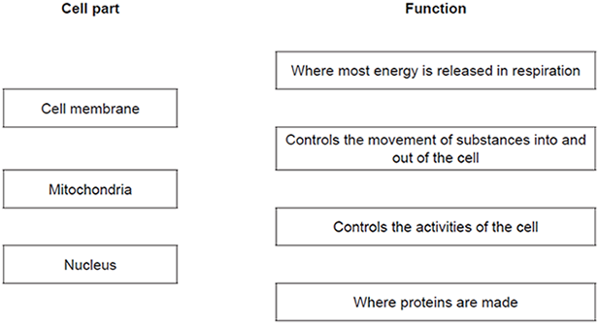
(3)
(b) The diagram below shows a cell from a plant leaf.
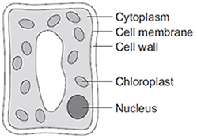
Which two parts in the diagram above are not found in an animal cell?
(2)
(Total 5 marks)
Q2.
Gas exchange takes place in the lungs.
The diagram shows an alveolus next to a blood capillary in a lung.
The arrows show the movement of two gases, A and B.
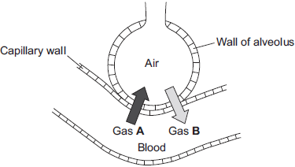
(a) (i) Draw a ring around the correct answer to complete the sentence.

Gases A and B move by | diffusion.  osmosis.  respiration.
(1)
(ii) Gas A moves from the blood to the air in the lungs.
Gas A is then breathed out.
Name Gas A.
(1)
(iii) Which cells in the blood carry Gas B?
Draw a ring around the correct answer.
platelets red blood cells white blood cells
(1)
(b) The average number of alveoli in each human lung is 280 million.
The average surface area of 1 million alveoli is 0.25 m².
Calculate the total surface area of a human lung.
(2)
(c) An athlete trains to run a marathon. The surface area of each of the athlete’s lungs has increased to 80 m².
Give one way in which this increase will help the athlete.
(1)
(Total 6 marks)
Q3.
The structures of four substances, A, B, C and D, are represented in Figure 1.
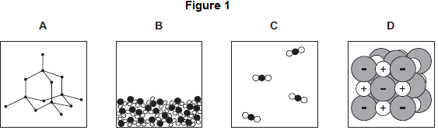
(a) Use the correct letter, A, B, C or D, to answer each question.

(i) | Which substance is a gas?
(1)

(ii) | Which substance is a liquid?
(1)

(iii) | Which substance is an element?
(1)

(iv) | Which substance is made of ions?
(1)
(b) Figure 2 shows the bonding in substance C.
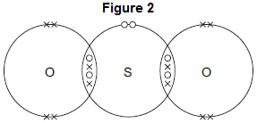
(i) What is the formula of substance C?
Draw a ring around the correct answer.

SO₂ | SO² | S₂O
(1)
(ii) Use the correct answer from the box to complete the sentence.

delocalised | shared | transferred
When a sulfur atom and an oxygen atom bond to produce substance C,
electrons are _____________________________________________
(1)
(iii) What is the type of bonding in substance C?
Draw a ring around the correct answer.

covalent | ionic | metallic
(1)
(Total 7 marks)
Q4.
The diagrams show the electronic structure of four different atoms.
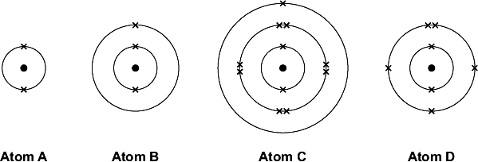
Use the Chemistry Data Sheet to help you to answer these questions.
(a) Name the two sub-atomic particles in the nucleus of an atom.
(1)
(b) Why is there no overall electrical charge on each atom?
(1)
(c) Why is Atom A unreactive?
(1)
(d) Which two of these atoms have similar chemical properties?
Give a reason for your answer.
(2)
(Total 5 marks)
Q5.
A ‘can-chiller’ is used to make a can of drink colder.
Figure 1 shows a can-chiller.
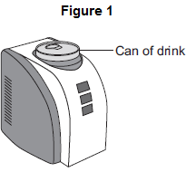
(a) The can-chiller decreases the temperature of the liquid in the can by 15 °C.
The mass of liquid is 0.33 kg.
The specific heat capacity of the liquid is 4200 J / kg °C.
Calculate the energy transferred from the liquid as it cools.
(2)
(b) Complete the following sentence.
The specific heat capacity of a substance is the amount of energy required to
change the _______________________________ of one kilogram of the
substance by one degree Celsius.
(1)
(c) To calculate the specific heat capacity of a material, the mass of the material needs to be measured.
State the name of a measuring instrument used to measure mass.
(1)
(d) The back of the can-chiller has cooling fins, as shown in Figure 2.
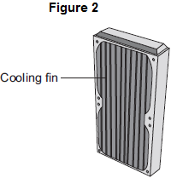
The cooling fins increase the rate of energy transfer from the can-chiller to the surroundings.
Complete the following sentences.
The cooling fins are a __________________ colour because that makes them
good emitters of infrared radiation.
The large surface area of the cooling fins allows the air around the can-chiller
to gain energy quickly and rise, transferring energy by __________________ .
(2)
(e) (i) The energy input to the can-chiller is the same as the energy output. This shows that energy is conserved.
Complete the following sentence.
Energy can be transferred usefully, stored or dissipated, but cannot be
_________________ or destroyed.
(1)
(ii) The temperature of the can of drink decreases while it is in the can-chiller.
What happens to the temperature of the air around the cooling fins?
(1)
(Total 8 marks)
Q6.
(a) The circuit diagram drawn below includes a component labelled X.
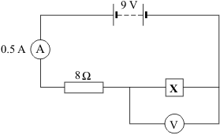
(i) Calculate the potential difference across the 8 ohm resistor.
Show clearly how you work out your answer.
(2)
(ii) What is the potential difference across component X?
(1)
(b) The graph shows how the resistance of component X changes with temperature.
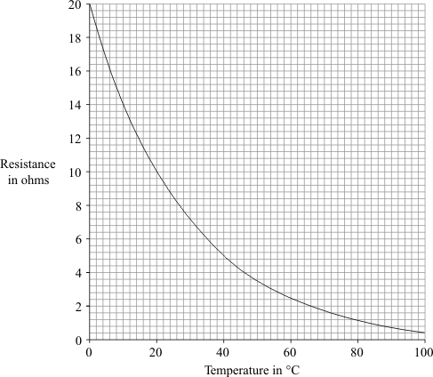
(i) What is component X?
(1)
(ii) Over which range of temperatures does the resistance of component X change the most?
Put a tick () next to your choice.

0 °C to 20 °C
20 °C to 40 °C
40 °C to 60 °C
60 °C to 80 °C
80 °C to 100 °C
(1)
(Total 5 marks)

