Term 2 IYG – Higher
Q1.
Gas exchange takes place in the lungs.
The diagram shows an alveolus next to a blood capillary in a lung.
The arrows show the movement of two gases, A and B.
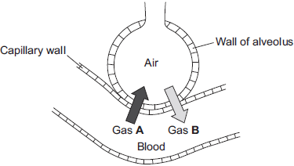
(a) (i) Draw a ring around the correct answer to complete the sentence.

Gases A and B move by | diffusion.  osmosis.  respiration.
(1)
(ii) Gas A moves from the blood to the air in the lungs.
Gas A is then breathed out.
Name Gas A.
(1)
(iii) Which cells in the blood carry Gas B?
Draw a ring around the correct answer.
platelets red blood cells white blood cells
(1)
(b) The average number of alveoli in each human lung is 280 million.
The average surface area of 1 million alveoli is 0.25 m².
Calculate the total surface area of a human lung.
(2)
(c) An athlete trains to run a marathon. The surface area of each of the athlete’s lungs has increased to 80 m².
Give one way in which this increase will help the athlete.
- (Total 6 marks)
Q2.
Diagrams A, B and C show cells from different parts of the human body, all drawn to the same scale.
A B C
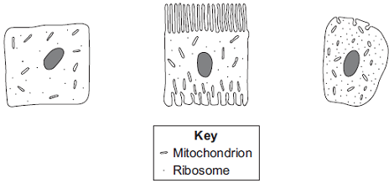
(a) Which cell, A, B or C, appears to be best adapted to increase diffusion into or
out of the cell?
Give one reason for your choice.
(1)
(b) (i) Cell C is found in the salivary glands.
Name the enzyme produced by the salivary glands.
(1)
(ii) Use information from the diagram to explain how cell C is adapted for producing this enzyme.
(2)
(Total 4 marks)

Q3.
The diagrams show the electronic structure of four different atoms.
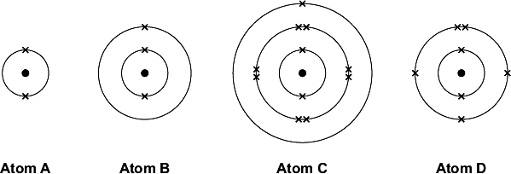
Use the Chemistry Data Sheet to help you to answer these questions.
(a) Name the two sub-atomic particles in the nucleus of an atom.
(1)
(b) Why is there no overall electrical charge on each atom?
(1)
(c) Why is Atom A unreactive?
(1)
(d) Which two of these atoms have similar chemical properties?
Give a reason for your answer.
(2)
(Total 5 marks)

Q4.
The drawing shows a high quality wire used to make electrical connections on a hi-fi system.
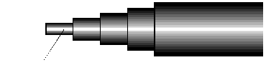
Multi-strand "OFC" copper
to maitain high signal purity
(a) Copper is used because it is a very good conductor of electricity. Copper is a typical metal.
(i) Describe the structure and bonding in a metal. You may wish to draw a diagram to help you to answer this question.
To gain full marks in this question you should write your ideas in good English. Put them into a sensible order and use the correct scientific words.
(3)
(ii) Explain, by reference to your answer to part (a)(i), why copper conducts electricity.
(1)
(iii) Explain, by reference to your answer to part (a)(i), why copper can be drawn into wires.
(1)
(b) The copper used to make this wire is “OFC” copper. This stands for ‘oxygen free copper’.
(i) It is thought that when molten copper is cooled and solidified it can take in some oxygen from the air. This may slightly decrease the conductivity of the copper.
Suggest why the conductivity might be decreased.
(2)
(ii) To make it oxygen free, the copper is heated in an atmosphere of hydrogen.
Explain how this will remove the oxygen.
(1)
(Total 8 marks)

Q5.
(a) The circuit diagram drawn below includes a component labelled X.
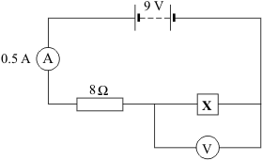
(i) Calculate the potential difference across the 8 ohm resistor.
Show clearly how you work out your answer.
(2)
(ii) What is the potential difference across component X?
(1)
(b) The graph shows how the resistance of component X changes with temperature.
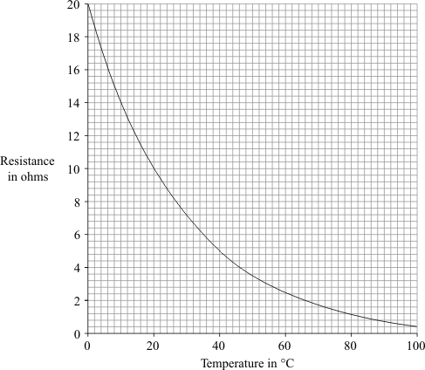
(i) What is component X?
(1)
(ii) Over which range of temperatures does the resistance of component X change the most?
Put a tick () next to your choice.

0 °C to 20 °C
20 °C to 40 °C
40 °C to 60 °C
60 °C to 80 °C
80 °C to 100 °C
(1)
(Total 5 marks)
Q6.
An electric immersion heater is used to heat the water in a domestic hot water tank.
When the immersion heater is switched on the water at the bottom of the tank gets hot.
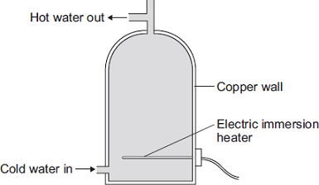
(a) Complete the following sentence.
The main way the energy is transferred through the copper wall of the water tank is
by the process of ________________________________________ .
(1)
(b) The immersion heater has a thermostat to control the water temperature.
When the temperature of the water inside the tank reaches 58°C the thermostat switches the heater off. The thermostat switches the heater back on when the temperature of the water falls to 50°C.
Graph A shows how the temperature of the water inside a hot water tank changes with time. The tank is not insulated.
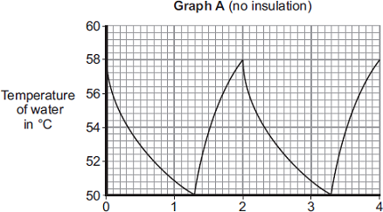
Time in hours
(i) The temperature of the water falls at the fastest rate just after the heater switches off.
Explain why.
(2)
(ii) To heat the water in the tank from 50°C to 58°C the immersion heater transfers 4032 kJ of energy to the water.
Calculate the mass of water in the tank.
Specific heat capacity of water = 4200 J/kg°C
(3)
(iii) An insulating jacket is fitted to the hot water tank.
Graph B shows how the temperature of the water inside the insulated hot water tank changes with time.
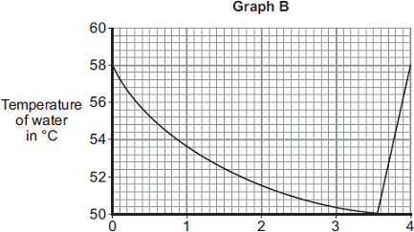
Time in hours
An insulating jacket only costs £12.
By comparing Graph A with Graph B, explain why fitting an insulating jacket to a hot water tank saves money.
(3)
(Total 9 marks)

