IYG Term 3
Q1.
This question is about compounds of oxygen.
The reaction between carbon and oxygen is exothermic.
(a) What does exothermic reaction mean?
(1)
(b) Which is the correct reaction profile (energy level diagram) for an exothermic reaction?
Tick one box.

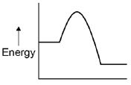
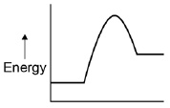
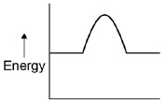
(1)
(c) The percentage by mass of oxygen in carbon dioxide (CO₂) is calculated by the equation:
Relative atomic masses (A_{r}): C = 12 O = 16
Calculate the percentage by mass of oxygen in carbon dioxide (CO₂).
(3)
Hydrogen peroxide decomposes to produce water and oxygen.
(d) Balance the chemical equation.
____ H₂O₂ → ____H₂O + O₂
(1)
(e) 6.8 g of hydrogen peroxide decomposes to produce 3.6 g of water.
Calculate the mass of oxygen produced when 68 g of hydrogen peroxide decomposes.
(2)
(Total 8 marks)
Q2.
This question is about lithium and sodium.
(a) Use the Chemistry Data Sheet to help you to answer this question.
In which group of the periodic table are lithium and sodium? Group
(1)
(b) A lithium atom can be represented as
The diagram represents the lithium atom.
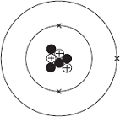
(i) Some particles in the nucleus have a positive charge.
What is the name of these particles?
(1)
(ii) Some particles in the nucleus have no charge.
What is the name of these particles?
(1)
(iii) Use the correct answer from the box to complete the sentence.

3 | 4 | 7
The mass number of this atom of lithium is
(1)
(c) Sodium reacts with chlorine to produce sodium chloride.
sodium + chlorine sodium chloride
The diagram shows how the reaction happens.
Only the outer electrons are shown.
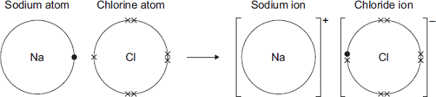
Draw a ring around the correct answer to complete each sentence.
 | gaining
(i) A sodium atom changes into a sodium ion by | losing | an electron.
 | sharing
(1)

 | a negative
(ii) A sodium ion has | no | charge.
 | a positive
(1)
(iii) The ions in sodium chloride are held together by

 | covalent
strong | electrostatic | forces.
 | magnetic
(1)
(d) Sodium chloride is an ionic compound.
Tick () two properties of ionic compounds.

Property | Tick ()
Do not dissolve in water
High melting points
Low boiling points
Strong bonds
(2)
(e) (i) The formula of sodium chloride is NaCl
Calculate the relative formula mass of sodium chloride.
Relative atomic masses: Na = 23; Cl = 35.5
(1)
(ii) Draw a ring around the correct answer to complete each sentence.
The relative formula mass of a substance, in grams,

 | ion
is one | isotope | of the substance.
 | mole
(1)
(f) Nanoparticles of sodium chloride (salt) are used to flavour crisps.
What are nanoparticles?
(1)
(Total 12 marks)
Q3.
A student investigated how the temperature of an oil affected the time taken for a metal ball to fall through the oil.
Figure 1 shows the apparatus.
Figure 1
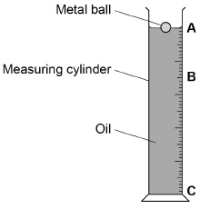
This is the method used.
1. Heat the oil.
2. Pour the oil into a measuring cylinder.
3. Drop the metal ball into the oil.
4. Record the time taken for the ball to fall from point A to point C.
5. Repeat steps 1–4 using different temperatures of the oil.
(a) Suggest why the student should not heat the oil directly with a flame.
(1)
(b) Suggest how the student could have heated the oil safely.
(1)
(c) What are two control variables in the investigation?
Tick two boxes.

Surface area of ball
Temperature of oil
Time taken for ball to fall
Volume of oil used
(2)
Figure 2 shows the metal ball falling through the oil.
Figure 2
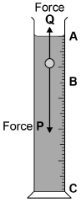
(d) What is force P?
(1)
(e) Between points A and B, force P is greater than force Q.
Which statement is correct?
Tick one box.

The ball has a constant speed
The ball is accelerating
The ball is not moving
(1)
(f) Between points B and C, the ball moves downwards at constant velocity.
Which statement is correct?
Tick one box.

Force P is larger than force Q
Force P is smaller than force Q
Force P and force Q are the same size
(1)
(g) The ball falls from B to C.
The value of force Q is 0.025 N
The distance between B and C is 0.20 m
Calculate the work done by force Q.
Use the equation:
work done = force × distance
(2)
(Total 9 marks)
Q4.
Figure 1 shows the forces acting on a car while it is moving.
Figure 1
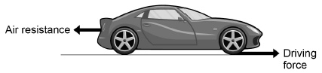
(a) What is the resultant force acting on the car when it is travelling at constant velocity?
(1)
(b) The car accelerates at 0.8 m/s²
The mass of the car is 850 kg
Calculate the resultant force acting on the car while it is accelerating.
Use the equation:
resultant force = mass × acceleration
(2)
(c) The driver notices a hazard and applies the brakes.
The car is travelling at 12 m/s
The driver’s reaction time is 0.180 s
Calculate the distance travelled during the driver’s reaction time.
Use the equation:
distance travelled = speed × time
(2)
(d) Figure 2 shows how the thinking distance, braking distance and stopping distance of a car change with speed.
Figure 2
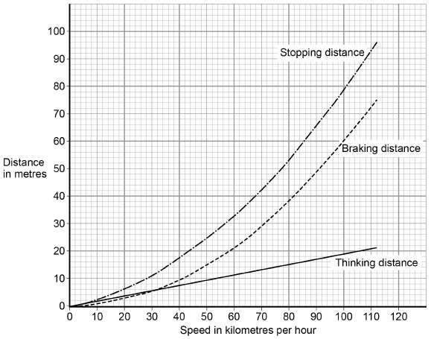
Describe the trends in the data in Figure 2.
(3)
(Total 8 marks)
Q5.
Figure 1 shows a fish called a carp.
Figure 1
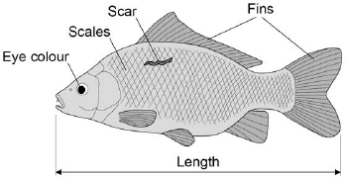
The characteristics of an animal can be a result of:
• only genetic causes
• only environmental causes
• both genetic and environmental causes.
(a) Give one characteristic shown in Figure 1 for each different cause.
(3)
(b) Two alleles control the body colour of carp:
• brown (B)
• blue (b).
The brown allele is dominant to the blue allele.
The genetic cross from breeding two carp is shown in Figure 2.
Figure 2
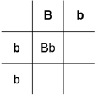
Complete Figure 2.
(2)
(c) Draw a ring around one blue offspring shown in Figure 2.
(1)
(d) What is the probability that the offspring from this genetic cross will be brown?
Tick two boxes.

0
0.25
0.5
1.0
(1)
(e) Carp can produce large numbers of offspring.
The two carp crossed in Figure 2 had 260 000 offspring.
Approximately how many offspring are expected to be brown?
(1)
(f) A pond contains carp used for breeding.
The carp for breeding are brown or blue.
A red carp has been seen.
The red carp was not added to the pond.
Suggest what might have caused the red carp to appear.
(1)
(Total 9 marks)
Q6.
This question is about evolution in humans.
The graph shows:
• the estimated brain volume of different species of humans
• the time when the different species existed on Earth.
The data is plotted for modern humans (Homo sapiens) and for three types of extinct ancestors of humans.
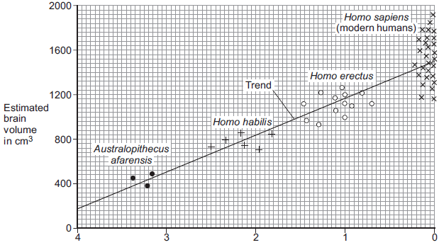
Millions of years ago
Key
Each point plotted on the graph shows the estimate for one human.
(a) (i) As humans evolved, their brain volume changed.
What has happened to human brain volume over the past 4 million years?
(1)
(ii) Why is the evidence for estimated brain volume for Homo sapiens stronger than the evidence for Australopithecus afarensis?
(1)
(b) In a book, the brain volume of a different species, Australopithecus africanus, is stated to be about 600 cm³.
Use evidence from the graphic above to estimate when Australopithecus africanus lived on Earth.
(1)
(c) Scientists believe that modern humans evolved by natural selection from Australopithecus afarensis.
(i) Complete the following sentence.
In the nineteenth century, the scientist who suggested the theory of evolution
by natural selection was Charles ____________________________ .
(1)
(ii) In the nineteenth century, many people did not accept this scientist’s theory.
Give one reason why.
(1)
(Total 5 marks)

