Term 3 IYG Higher
Q1.
Some students investigated the change in temperature as sodium hydroxide solution is added to dilute sulfuric acid.
This is the method used.
1. Put 25 cm³ of dilute sulfuric acid into a polystyrene cup.
2. Measure the initial temperature of the dilute sulfuric acid.
3. Add 4 cm³ of sodium hydroxide solution to the dilute sulfuric acid.
4. Stir the mixture.
5. Measure the highest temperature of the mixture.
6. Repeat steps 3‒5 until 40 cm³ of sodium hydroxide solution have been added.
Figure 1 shows the apparatus the student used.
Figure 1
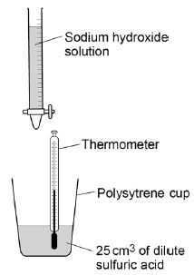

(a) The volume of sodium hydroxide solution is a variable.
Which two words can be used to describe this type of variable?
Tick two boxes.

Categoric
Continuous
Control
Dependent
Independent
(2)
(b) The dilute sulfuric acid has an initial temperature of 24.0 °C
Figure 2 shows the highest temperature.
Figure 2
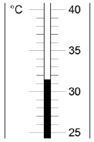
Calculate the change in temperature.
(2)

Figure 3 shows the students’ results.
Figure 3
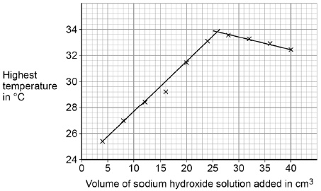
(c) Determine the volume of sodium hydroxide solution that gives the highest temperature change.
Use Figure 3 to help you answer this question.
(1)
(d) In Figure 3 the temperature when 16 cm³ of sodium hydroxide solution is added is anomalous.
Suggest one error that could have been made in the method which would cause this anomalous result.
(1)
(e) The sodium hydroxide solution in this investigation contains 80 grams per dm³
The students use 40 cm³ of sodium hydroxide solution.
Calculate the mass of sodium hydroxide in 40 cm³
(3)
(Total 9 marks)

Q2.
This question is about atoms and isotopes.
(a) Atoms contain protons, neutrons and electrons.
A lithium atom has the symbol
Explain, in terms of sub-atomic particles, why the mass number of this lithium atom is 7.
(3)
(b) Amounts of substances can be described in different ways.
Complete the sentences.
One mole of a substance is the relative formula mass in
The relative atomic mass of an element compares the mass of an atom of an element with the mass of an atom of
(2)
(c) Two isotopes of oxygen are and
Describe the similarities and differences between the isotopes and
You should refer to the numbers of sub-atomic particles in each isotope.
(3)
(Total 8 marks)

Q3.
Figure 1 shows an electric wheelchair.
Figure 1
(a) The wheelchair moves at a constant speed of 2.4 m/s for 4.5 seconds.
Calculate the distance moved by the wheelchair.
Use the equation:
distance = speed × time
(2)
(b) What could be a reason for the speed of the wheelchair decreasing?
Tick one box.

It started going downhill.
It started going uphill.
Its store of kinetic energy increased.
It used more power from its battery.
(1)

A student measured how the distance travelled by the wheelchair changed over time.
Figure 2 shows a sketch-graph of the results.
Figure 2
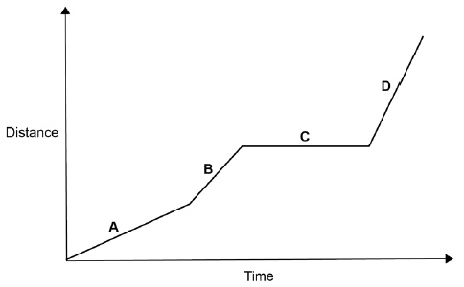
(c) In which section of the graph, A, B, C, or D, did the wheelchair travel fastest?
Give the reason for your answer.
(2)
(d) The student used a data logger with a distance sensor to record the data.
Give two advantages of using a data logger rather than using a stopclock and tape measure.
(2)

The velocity of the wheelchair changes as it accelerates to its top speed.
Figure 3 shows a sketch-graph of the changes.
Figure 3
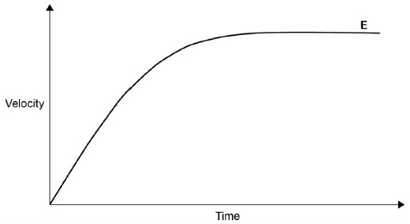
(e) The forward force on the wheelchair is constant as it accelerates on flat ground.
Which force reduces the acceleration?
Tick one box.

Air resistance
Magnetism
Tension
Weight
(1)
(f) Explain the acceleration of the wheelchair at point E on Figure 3.
(2)
(g) The wheelchair starts from rest.
It accelerates at a constant rate until it has a speed of 1.5 m/s
The wheelchair travels a distance of 2.0 m while it is accelerating.
Calculate the acceleration of the wheelchair.
Using the Physics Equations Sheet.
(3)
(Total 13 marks)
Q4.
A student investigated the relationship between the force applied to a spring and the extension of the spring.
This is the method used.
1. Hang a spring from a rod.
2. Hang a mass from the spring.
3. Measure the extension of the spring.
4. Repeat steps 2 and 3 using different masses.
Figure 1 shows a spring before and after a mass had been hung from it.
Figure 1
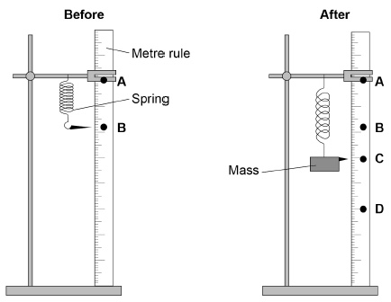
(a) Give two ways in which the appearance of the spring has changed.
(2)
(b) The extension of the spring is the distance between which two points on the metre rule?
Use letters from the diagram in Figure 1.
(1)
(c) The force applied to the spring is the weight of the mass hanging from the spring.
Write the equation that links gravitational field strength, mass and weight.
(1)

Figure 2 shows the student’s results.
Figure 2
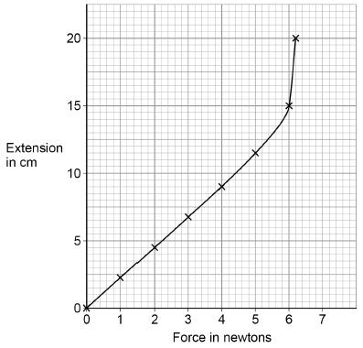
(d) During the investigation the limit of proportionality of the spring was exceeded.
What is the value of force at which this happened?
Give a reason for your choice.
(2)
(e) Suggest how the student could obtain a more accurate answer for the limit of proportionality of the spring.
You should include the additional readings the student should take.
(2)
(f) Write the equation that links extension, force and the spring constant.
(1)
(g) A different spring has a spring constant of 18 N/m
When an apple is hung from the spring, the spring extends 6.4 cm
The spring does not go past the limit of proportionality.
Calculate the force exerted by the apple on the spring.
(3)
(Total 12 marks)

Q5.
Moose are animals that eat grass.
Figure 1 shows a moose.
Figure 1
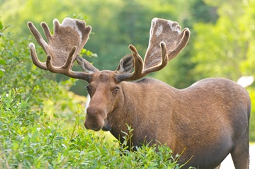
© Wildnerdpix/iStock/Thinkstock
Figure 2 shows a food chain.
Figure 2
Grass Moose Wolves
(a) Name the secondary consumer shown in Figure 2.
(1)
(b) Figure 3 shows how the moose population and wolf population have changed in one area.
This is a predator-prey cycle.
Figure 3
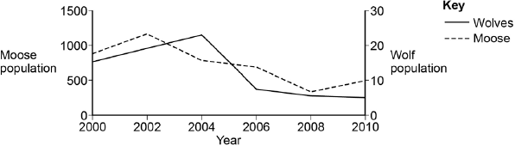
In 2004 the line on Figure 3 for wolves is above the line for moose.
How does Figure 3 show that there are more moose than wolves in 2004?
(1)

(c) Suggest why the moose population decreased between 2002 and 2004.
Use information from Figure 3.
(1)
(d) The number of wolves is one biotic factor that could affect the size of the moose population.
Give two other biotic factors that could affect the size of the moose population.
(2)
(e) Moose have distinct characteristics such as antlers.
Describe how moose may have evolved to have large antlers.
(5)
(Total 10 marks)

Q6.
The diagrams show fossil animals found in rocks of different ages. Scientists have used this information to work out how the modern horse evolved.
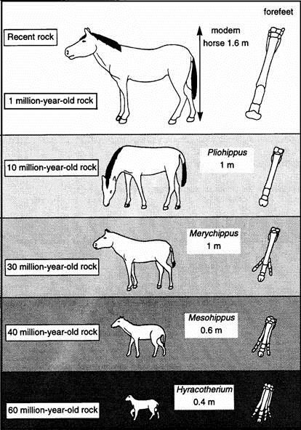
(a) Mesohippus became extinct over thirty million years ago. Use information from the diagrams to suggest two reasons why this happened.
(2)
(b) (i) How do scientists know how big these early horses were?
(1)
(ii) How do scientists know when they lived?
(1)
(c) Explain how the information in the diagrams supports the theory of evolution.
(3)
(Total 7 marks)

